
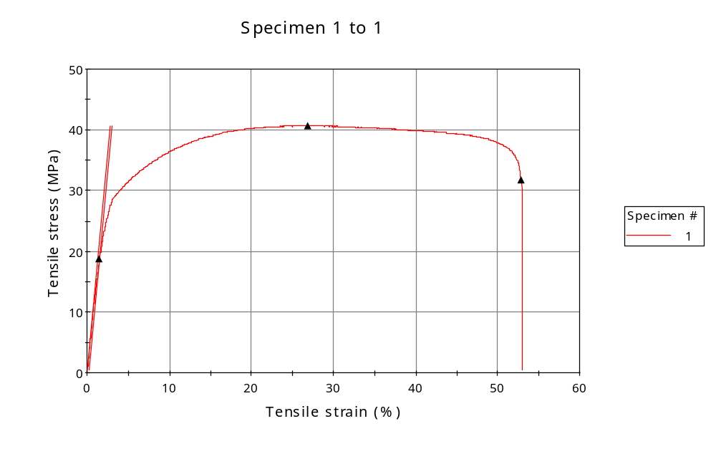
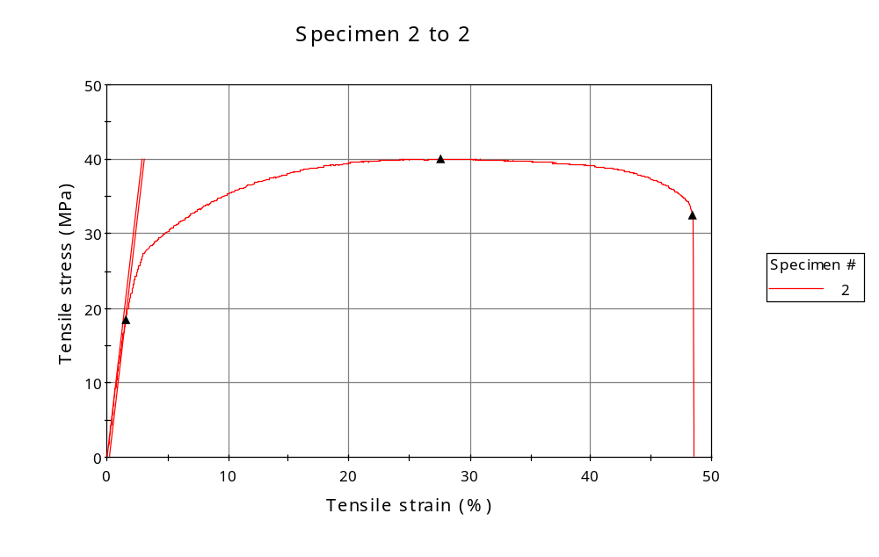
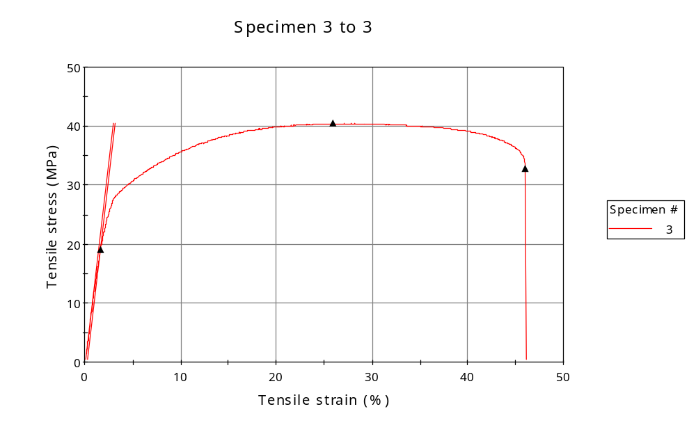
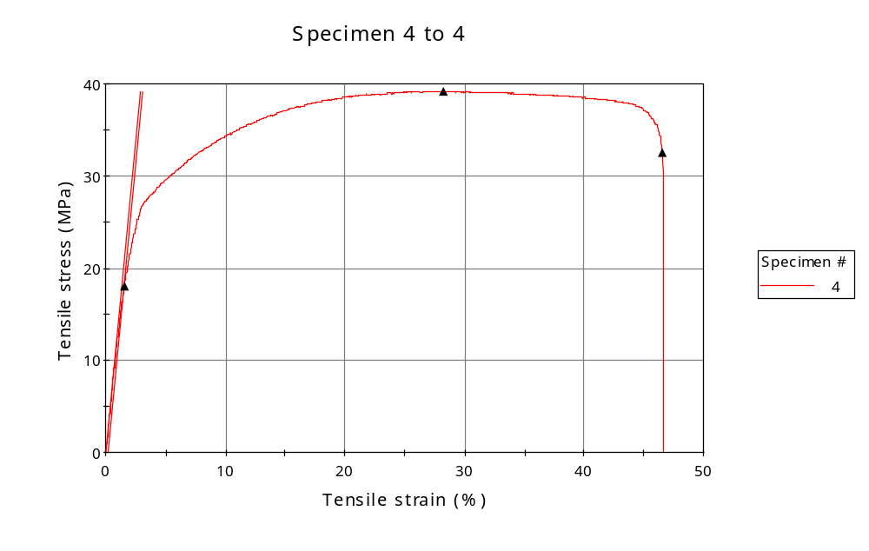
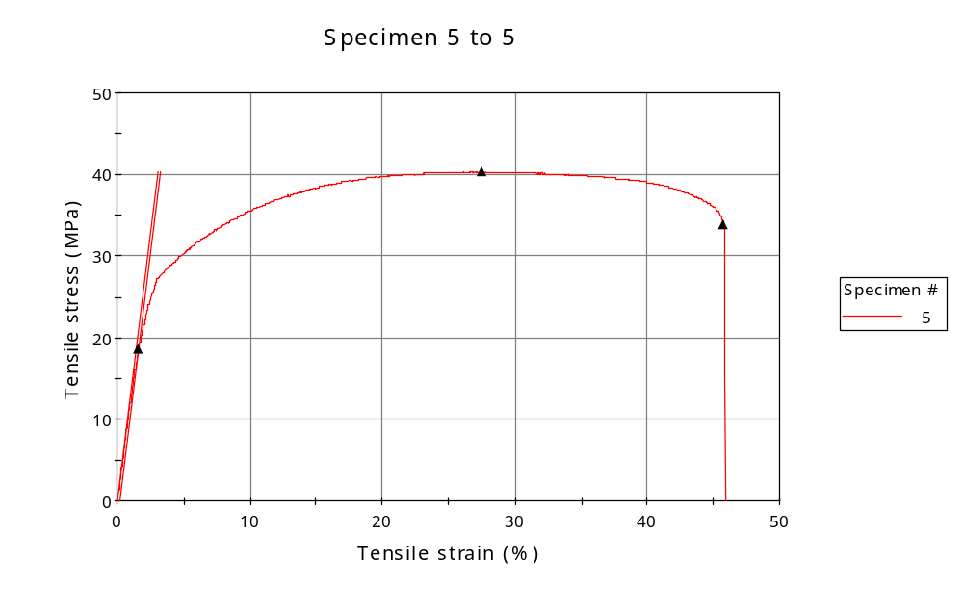
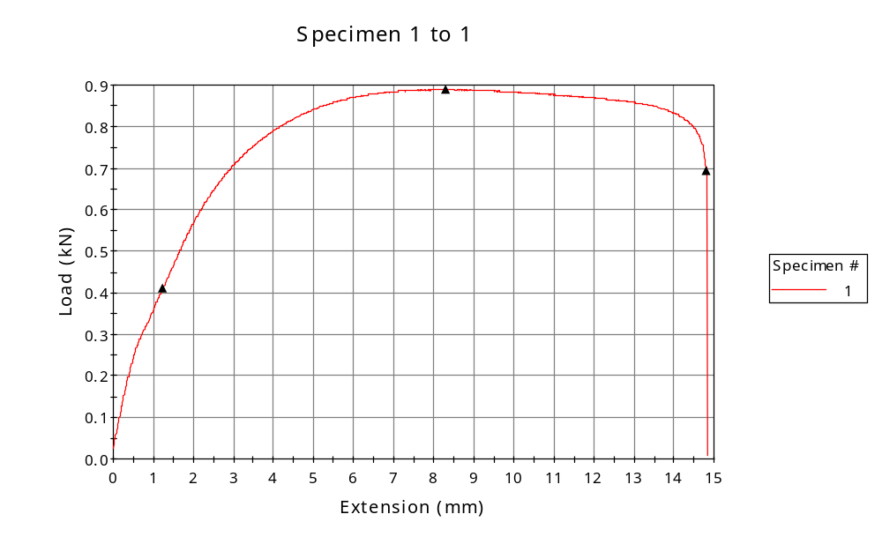
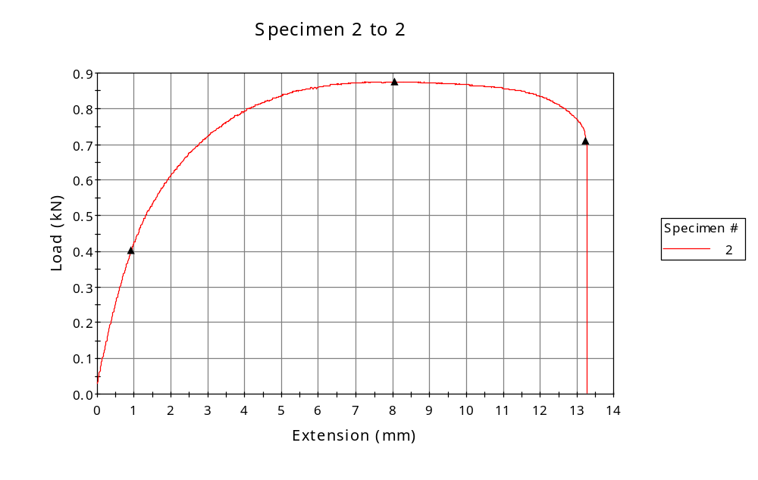
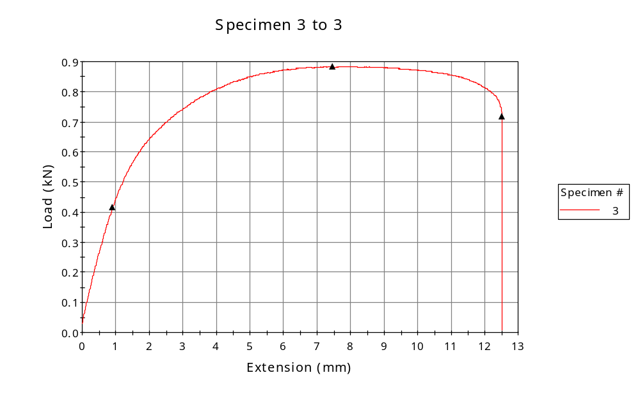
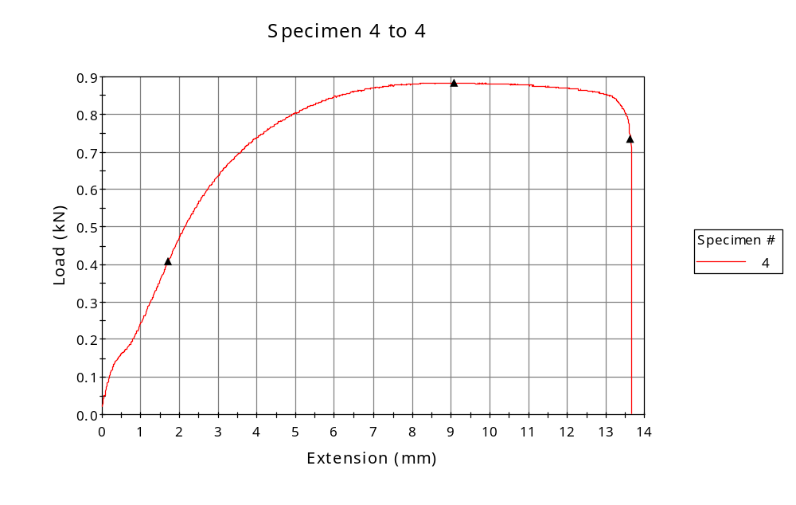
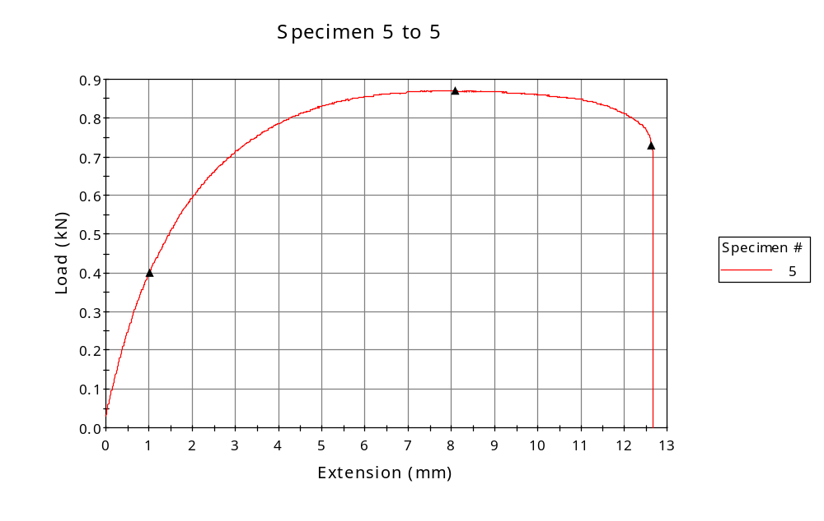

 | CP ID | Length  (mm) | Width  (mm) | Thickness  (mm) | Modulus (Automatic Young's)  (MPa)
1 | CP-SLS_YZ4_01 | 25.00 | 6.34 | 3.45 | 1437
2 | CP-SLS_YZ4_02 | 25.00 | 6.25 | 3.50 | 1388
3 | CP-SLS_YZ4_03 | 25.00 | 6.34 | 3.45 | 1403
4 | CP-SLS_YZ4_04 | 25.00 | 6.38 | 3.54 | 1359
5 | CP-SLS_YZ4_05 | 25.00 | 6.28 | 3.44 | 1335
Maximum |  | 25.00 | 6.38 | 3.54 | 1437
Minimum |  | 25.00 | 6.25 | 3.44 | 1335

 | Load at Fy ( 0.2 %) - LE  (kN) | Tensao em Fy ( 0.2 %) - LE  (MPa) | Deformacao em Fy ( 0.2 %) - LE  (%) | Forca Max  (kN) | Tensao na Forca Max - LR  (MPa)
1 | 0.411 | 19 | 1.505 | 0.889 | 41
2 | 0.403 | 18 | 1.541 | 0.876 | 40
3 | 0.415 | 19 | 1.629 | 0.884 | 40
4 | 0.407 | 18 | 1.540 | 0.885 | 39
5 | 0.401 | 19 | 1.618 | 0.870 | 40
Maximum | 0.415 | 19 | 1.629 | 0.889 | 41
Minimum | 0.401 | 18 | 1.505 | 0.870 | 39

 | Deformacao na Forca Max - LR  (%) | Forca na Forca na Quebra - LQ  (kN) | Deformacao na Forca na Quebra - LQ  (%) | Final length  (mm) | Final width  (mm)
1 | 26.897 | 0.693 | 52.864 | 119.00 | 6.82
2 | 27.646 | 0.710 | 48.413 | 119.00 | 6.82
3 | 25.884 | 0.718 | 46.050 | 119.00 | 6.82
4 | 28.287 | 0.734 | 46.521 | 119.00 | 6.82
5 | 27.556 | 0.729 | 45.756 | 119.00 | 6.82
Maximum | 28.287 | 0.734 | 52.864 | 119.00 | 6.82
Minimum | 25.884 | 0.693 | 45.756 | 119.00 | 6.82

 | Alongamento
1 | 3.76
2 | 3.76
3 | 3.76
4 | 3.76
5 | 3.76
Maximum | 3.76
Minimum | 3.76

